Web Application Security Audit Report
of
Department of FCSCA.
Website: http://10.247.176.228/
Submitted By
Secnic Consultancy

Report Release Date | 25.10.2025
Type of Audit | Application Security Aduit
Type of Audit Report | Level 1 Report
Period | Nov 04, 2025 to Nov 05, 2025

© 2025 Department of FCSCA.
All rights reserved. All information contained in this document is confidential and proprietary to Department of FCSCA. No part of this document may be photocopied, electronically transferred, modified, or reproduced in any manner without the prior written consent of Department of FCSCA.
All brands or product names are trademarks or registered trademarks of their respective companies or organisations.

Document Control

Document Preparations
Document Title | Application Security Audit Report
Document ID | Null
Document Version | 1.0
Prepared By
Reviewed By
Approved By
Released By
Released Date | Nov 04 2025

Document Change History

Version | Date | Remarks
1.0 | Nov 04, 2025 | Level 1 report

Document Distribution List

Name | Organization | Designation | Email Id
Atul Suri | Manager (Quality & Audit) | Department of FCSCA

Table of Contents

1. EXECUTIVE SUMMARY 3
1.1 Introduction 3
1.2 Scope 3
1.3 Summary of Findings 4
1.4 Overall Assessment 4
1.5 Key Vulnerabilities Discovered 5
2. OVERALL SUMMARY OF FINDINGS 6
3. BENCHMARKING WITH OWASP 6
4. KEY FINDINGS AND ACTION ITEMS 8
5. General Guidelines 16

EXECUTIVE SUMMARY

Introduction
This report presents the results of the penetration testing for the Department of FCSCA. Website (http://10.247.176.228/) The objective of the test was to find out vulnerabilities that can be seen and compromised by malicious users from the Internet. The application was found to be vulnerable to security risks including Security Misconfiguration, & Denial of Service issues etc... The following sections provide details of the scope of the penetration test, the IPs on which detailed penetration testing was conducted, and the detailed findings from the penetration testing exercise.

Our opinion provided in this report is valid for the period during which the penetration testing was carried out and is based on the information and the website contents provided for audit. Projection of any conclusions based on our findings for future periods and application versions is subject to the risk that the validity of such conclusions may be altered because of changes made to the network or application or system or the failure to make the changes to the network, application, system when required.

Disclaimers and Restrictions
- Organization’s management is responsible for its assertions. Our responsibility is to express an opinion on management’s assertion based on our audit.
- The audit was conducted in accordance with the Information Systems Auditing Standards issued by the Standards Board of Information Systems Audit and Control Association. Further, the objective of the audit was to obtain reasonable assurance that the assertion is not materially misstated. Our audit included
  - Obtaining an understanding of the objectives;
  - selectively testing these objectives;
  - testing and evaluating; and
  - performing such other procedures as we considered necessary under the circumstances. We believe that our audit provides a reasonable basis for our opinion.
- Because of inherent limitations in controls, errors or fraud may occur and may not be detected. Furthermore, the projection of any conclusions, based on our findings, to future periods are subject to the risk that changes made to the system or controls, changes in processing requirements, changes required because of the passage of time, or degree of compliance with the policies or procedures may alter the validity of such conclusions.
- This report is strictly to be used for the intend purpose of compiling the controls being followed for the purposes of analysis and improvement.
- It is firmly recommended to test out all our technical recommendations to the system internals such as services or registry in a test environment and the impact on the reliability and integrity of the system be evaluated before rolling out the changes to the production environment.
- This report does not include any representation on the financial, marketing, human resources or any other health of the Organization or on the future viability of the Organization or minimizing or exposure of all risks associated with computerized environment, due to its inherent limitations.

Details of the Auditing Team
Sr. No. | Name | Designation | Email Id | Professional Qualifications/ Certifications | Whether the resource has been shortlisted in the snapshot information published on Cert-In’s website (Yes/No)
1 |  |  |  | CISA, ISO 27001 LA | Yes
2 |  |  |  | ISO LA | Yes
3 |  |  |  | CEH | Yes

Audit Activities and Timelines

Audit Phases | Timelines
Receipt of URL/Application Auditee for Audit | Nov 04, 2025
Execution of Assignment
Report Preparation
Report Submission to Auditee | Nov 05, 2025

Audit Methodology and Criteria / Standard referred for audit
During the course of this review, we assessed the activities as stated above for compliance with OWASP & other known vulnerabilities and best practices, as applicable. We conducted the assignment using automated tools and conducting manual testing, as applicable.

Tools/Software Used

Sr. No. | Name of Tool/Software Used | Version of the tool/Software used | Open Source/Licensed
1. | Burp Suite Professional | 2024.5 | Licensed
2. | Invicti Standard | 25.5.1 | Licensed
3. | Kali Tools |  | Open Source
4. | Manual scripts

Scope
The following table details an overview on the scope of the penetration test.

Details
Application Name | SCPWD
Testing IP/URL | http://10.247.176.228/
Mode of Test | Grey Box Testing

Summary of Findings
Penetration testing on the Website (http://10.247.176.228/ ) was performed for a period of 1 days. As a result of the penetration test following risks were identified:
No of Findings | Critical | High | Medium | Low
10 | 0 | 4 | 6 | 0

The table below gives an overall result of the findings from the penetration testing exercise. The “Key Findings and Action Items” section gives the details of the vulnerabilities and provides the recommendations to mitigate them.

Overall Assessment
We have identified 10 vulnerabilities during the penetration testing of the (http://10.247.176.228/). The team concluded the risks based on the results of the various tests carried out during the penetration testing process. The following table lists down the key vulnerabilities discovered.

Key Vulnerabilities Discovered
Sr. No. | VULNERABILITY | RISK LEVEL | REMARKS &  ACTION ITEMS
1. | XSLT Injection | High | User input is passed to XSLT processor without proper validation, allowing execution of malicious XSLT code.
2. | Random Domain via msfconsole (Penetration Test) | High | During penetration testing using Metasploit, requests went to unexpected domains indicating misconfiguration or SSRF.
3. | Missing SSL Certificate | High | Application does not use HTTPS, or SSL certificate is absent/invalid.
4. | Transmitted over HTTP | High | Sensitive data transmitted over HTTP instead of HTTPS.
5. | External Link (Untrusted Links) | Medium | The application contains links to external domains which may be malicious or untrusted.
6. | jQuery Migrate (Deprecated / Vulnerable Library) | Medium | Application uses outdated jQuery Migrate library which may contain known vulnerabilities.
7. | Missing Frame Ancestor (Clickjacking Protection Missing) | Medium | X-Frame-Options or Content-Security-Policy frame-ancestors header missing, allowing app to be embedded in other sites.
8. | Server Error | Medium | Application returns internal server errors exposing stack trace or sensitive information.
9. | jQuery Version Disclosure | Medium | Web application publicly exposes the exact jQuery version used (via script filename, jQuery.fn.jquery, comments, or library meta).
10 | Potential SSDP/UPnP service on UDP 190 | Medium | UDP 1900 (SSDP) appears reachable. SSDP/UPnP can disclose device information and — if enabled— allow dynamic port mappings that may expose internal services to the outside.

OVERALL SUMMARY OF FINDINGS
Below Chart gives the overall summary of number of Vulnerabilities discovered with the Risk rating. Total of 09 vulnerabilities High-4 medium-5 Low-0 Informational-0 level Vulnerabilities were reported.

BENCHMARKING WITH OWASP
The below chart depicts the number of discovered vulnerabilities mapped to OWASP Testing Category.

OWASP has rated the Top Ten Vulnerabilities found in web applications worldwide. OWASP Top Ten Vulnerabilities details can be found at below link.

https://owasp.org/Top10/

The table shows the application vulnerability mapped with respect to the OWASP Top 10 - 2021 list.

Sl. No | Vulnerabilities | Status
1 | Injection Flaws | Unprotected
2 | Broken Authentication | Unprotected
3 | Sensitive Data Exposure | Unprotected
4 | XML External Entities (XXE) | PROTECTED
5 | Broken Access Control | Unprotected
6 | Security Misconfiguration | Unprotected
7 | Cross-Site Scripting (XSS) | Unprotected
8 | Insecure Deserialization | protected
9 | Using Components with Known Vulnerabilities | Unprotected
10 | Insufficient Logging & Monitoring | protected

Tools | Used
- Burp Suite | 8
- Kali Linux | 1
Browser | 1
OWASP ZAP | 1

KEY FINDINGS AND ACTION ITEMS

- XSLT injection
Brief Description | Risk Rating | Impact on Application | Probability of Attack
User input is passed to XSLT processor without proper validation, allowing execution of malicious XSLT code. | High | High | High
Impact:

Data leakage, server-side code execution, sensitive information exposure.

Affected items
http://10.247.176.228/wp-login.php

Proof of Concept:
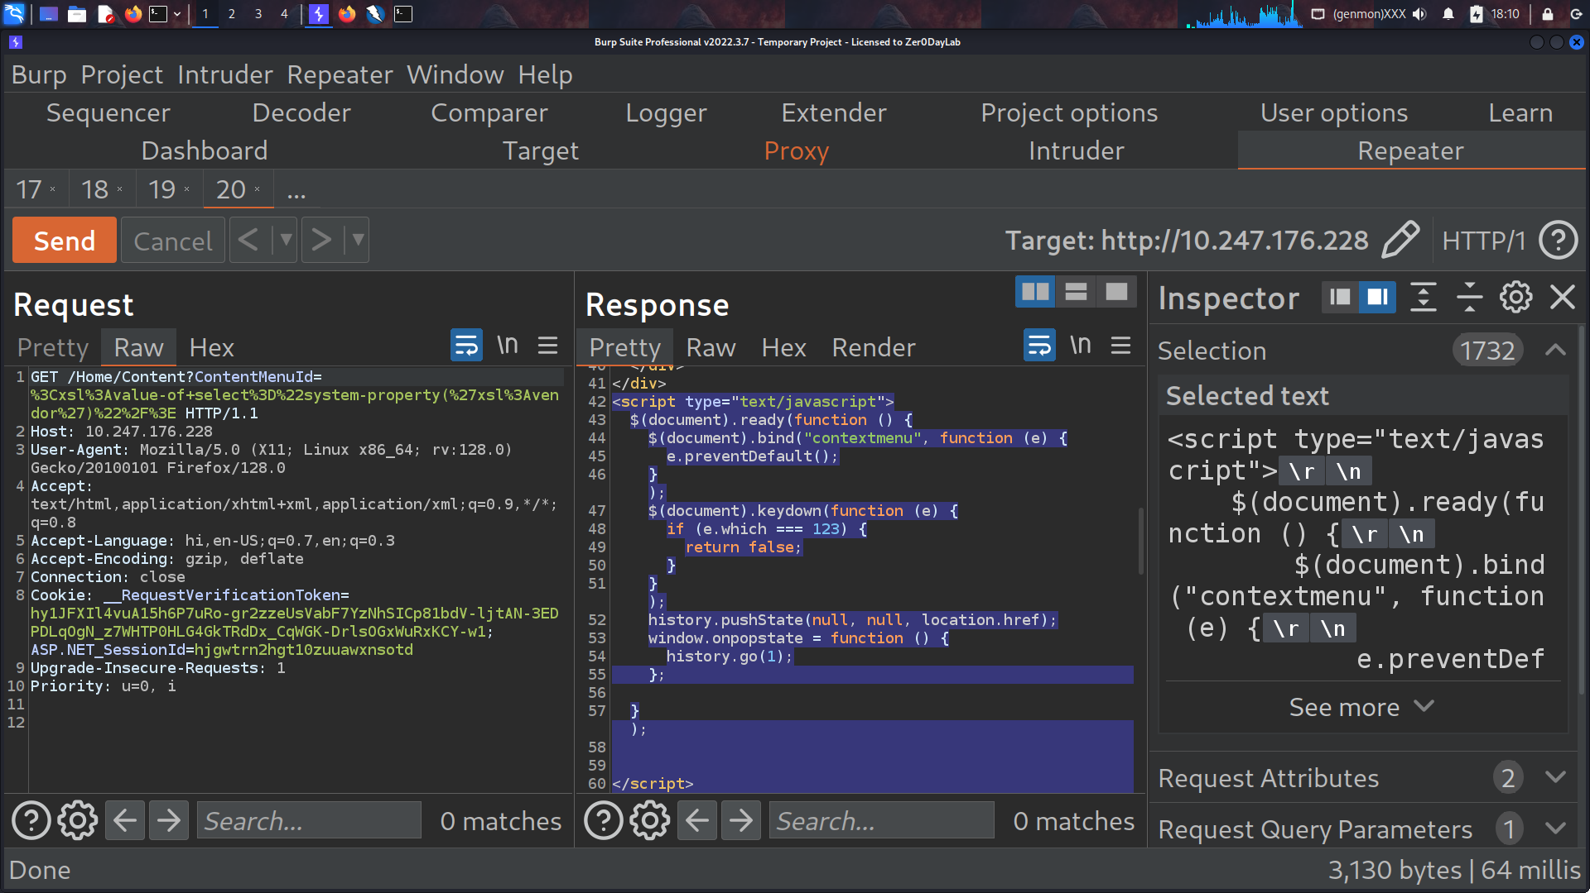
Recommendation:- Use parameterized XSLT APIs. Run transformations in sandboxed mode with external resource fetching disabled. Implement strict allowlist validation.
Tool Used:- Burpsuite

- Random Domain via msfconsole
Brief Description | Risk Rating | Impact on Application | Probability of Attack
During penetration testing using Metasploit, requests went to unexpected domains indicating misconfiguration or SSRF. | High | High | Medium
Impact:
Information disclosure, potential server-side request forgery (SSRF).

Affected items
http://10.247.176.228/Home/content?ContentMenuId=2
http://10.247.176.228/FAQ/FAQ

Proof of Concept:-
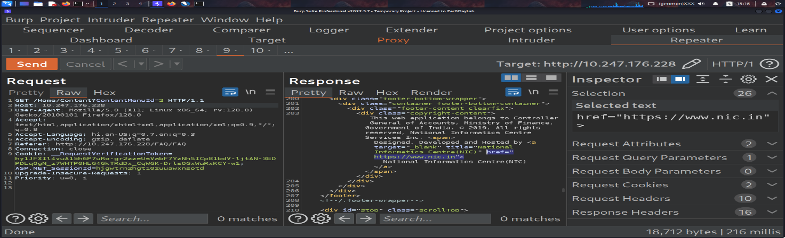
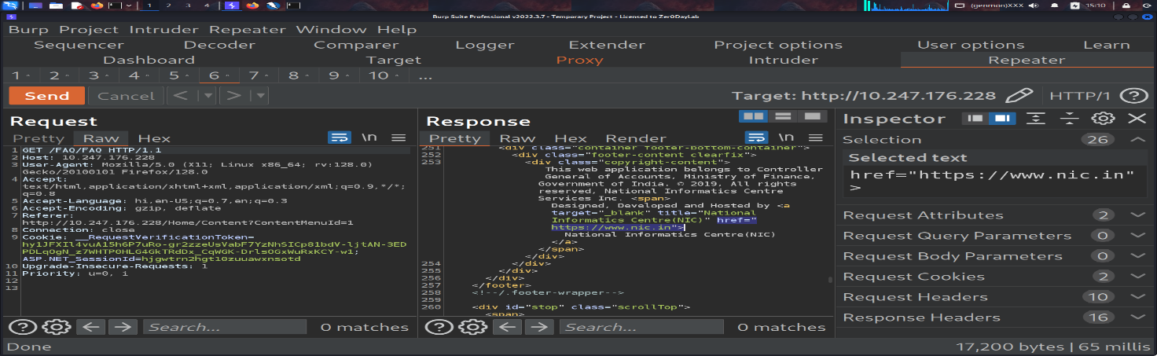
Recommendation:- Validate and sanitize all server-side URL requests; use allowlist for permitted hosts; disable internal/external network access for user-controlled requests. Log and alert on unexpected outbound requests.
Tool Used:- Burpsuite

- Missing SSL Certificate
Brief Description | Risk Rating | Impact on Application | Probability of Attack
Application does not use HTTPS, or SSL certificate is absent/invalid. | High | High | High
Impact:
Data transmitted in plaintext, susceptible to eavesdropping, MITM attacks.
Affected items:
http://10.247.176.228/
Proof of Concept:
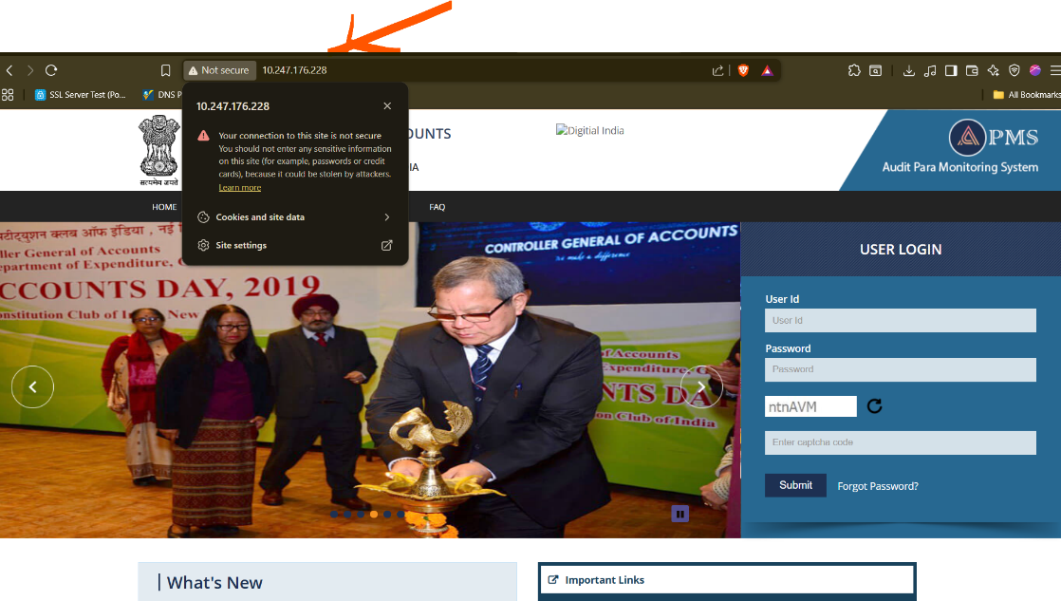

Recommendation:- Enforce TLS 1.2/1.3, disable weak ciphers, enable HSTS (Strict-Transport-Security), and automate certificate renewal. Monitor expiry continuously.

Tool Used:- Browser

- Transmitted over HTTP
Brief Description | Risk Rating | Impact on Application | Probability of Attack
Sensitive data transmitted over HTTP instead of HTTPS. | High | High | High
Impact:
Eavesdropping, session hijacking, credentials leakage.

Affected items
http://10.247.176.228/

Proof of Concept:

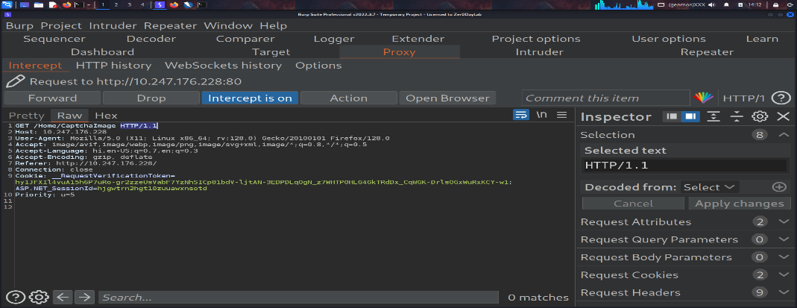

Recommendation:- Enforce HTTPS site-wide with HSTS, use HttpOnly; Secure; SameSite=Strict for cookies, audit endpoints for plaintext data, and encrypt sensitive information in transit.

Tool Used:- Burpsuite

- Found External Link
Brief Description | Risk Rating | Impact on Application | Probability of Attack
The application contains links to external domains which may be malicious or untrusted. | Medium | Medium | High

Impact: Phishing, malware distribution, user redirection to harmful sites.

Affected items
http://10.247.176.228/Content?ContentMenu=2
Proof of Concept:

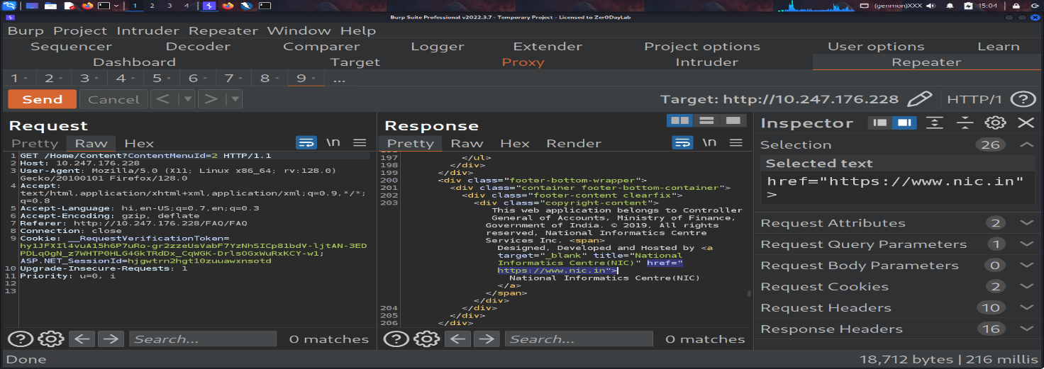

Recommendation:- Validate and sanitize all server-side URL requests; use allowlist for
permitted hosts; disable internal/external network access for user-controlled requests. Log and alert on unexpected outbound requests.

Tool Used:- Burpsuite

- JQuery Migrate (Deprecated / Vulnerable Library)
Brief Description | Risk Rating | Impact on Application | Probability of Attack
Application uses outdated jQuery Migrate library which may contain known vulnerabilities. | Medium | Medium | High
Impact:
Client-side attacks, XSS, exploitation via known vulnerabilities.
Affected items:
http://10.247.176.228/
Proof of Concept:
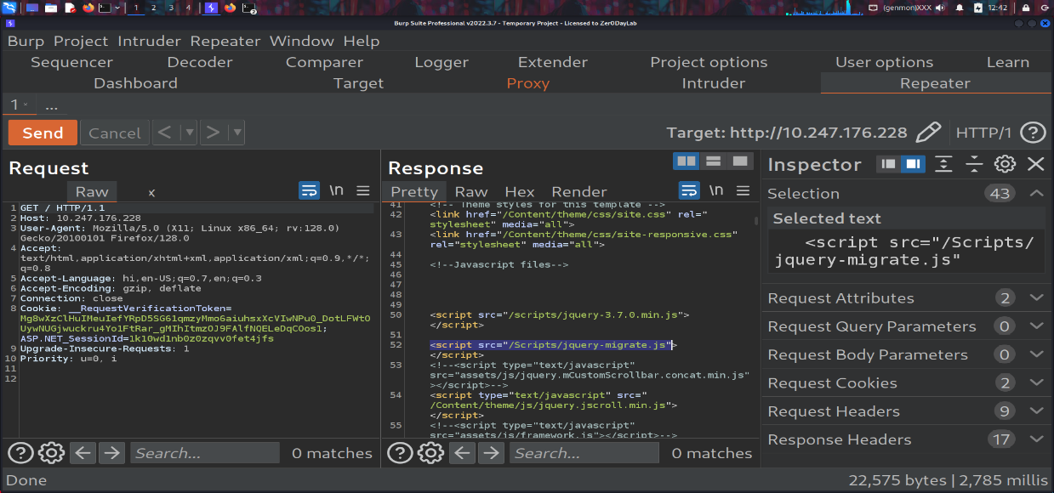

Recommendation:- Upgrade jQuery and all dependent plugins to latest stable versions. Refactor deprecated APIs and test functionality. Use SRI for CDN scripts.
Tool Used:- Burpsuite

- Missing Frame Ancestor (Clickjacking Protection Missing)
Brief Description | Risk Rating | Impact on Application | Probability of Attack
X-Frame-Options or Content-Security-Policy frame-ancestors header missing, allowing app to be embedded in other sites. | Medium | Medium | High
Impact: Clickjacking attacks (tricking users to perform unintended actions).
Affected items
http://10.247.176.228/Feedback/ViewAllwhatsnews
Proof of Concept:
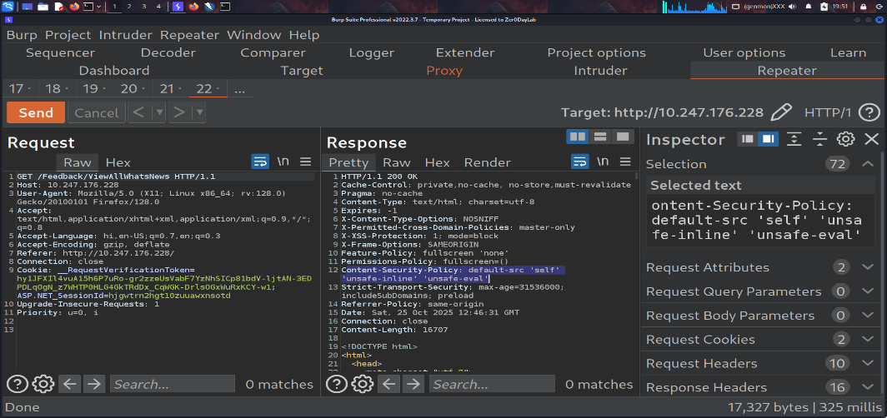

Recommendation:- Implement CSP header: Content-Security-Policy: frame-ancestors 'self' https://trusted.example. Apply across all responses, especially authentication pages.

Tool used: Burpsuite

- Server Error (500 / 502 /)
Brief Description | Risk Rating | Impact on Application | Probability of Attack
Application returns internal server errors exposing stack trace or sensitive information. | Medium | Medium | Medium
Impact: Information disclosure, may aid attackers in crafting further attacks.
Affected items
http://10.247.176.228/Home/login

Proof of Concept:-
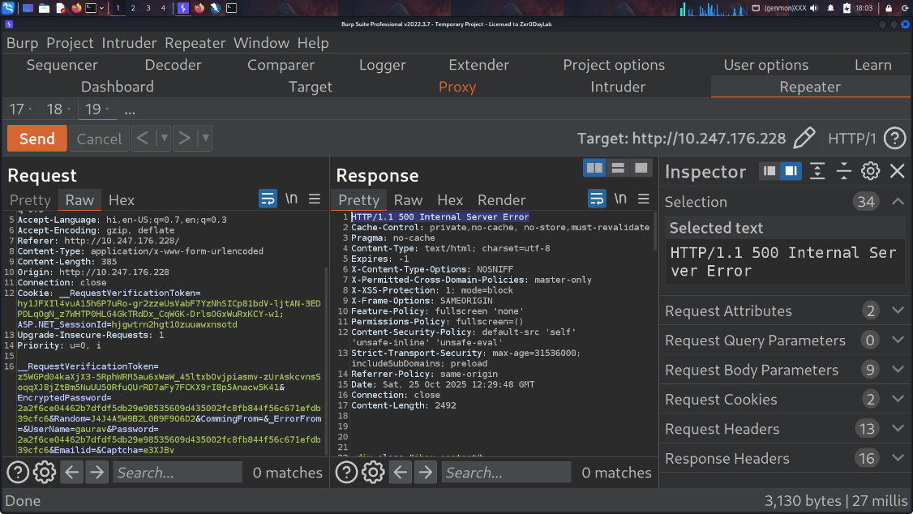

Recommendation:- Implement structured error handling and centralized logging; sanitize exception messages before displaying; restrict log access to authorized personnel only.
Tool used: Burp Suite

- JQuery version Disclousre
Brief Description | Risk Rating | Impact on Application | Probability of Attack
Web application publicly exposes the exact jQuery version used (via script filename, jQuery.fn.jquery, comments, or library meta). | Medium | Medium | High

Impact: Attackers can check if that jQuery version has known vulnerabilities (XSS, prototype-pollution, etc.). If vulnerable, they may craft targeted exploits. Even if current version is safe, disclosure helps fingerprinting and attack planning.

Affected items
http://10.247.176.228/
Proof of Concept:
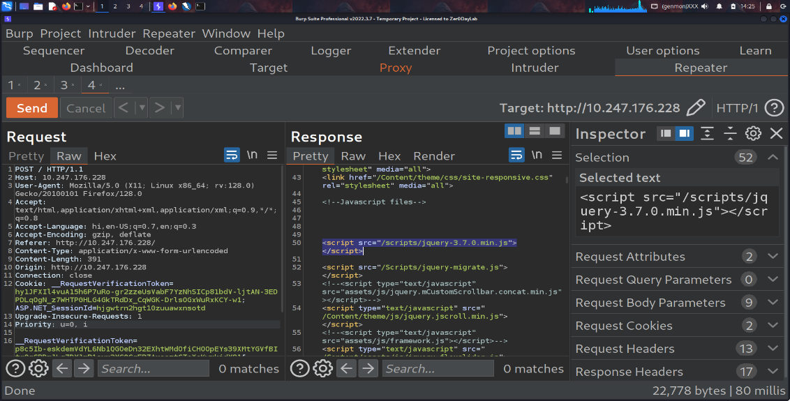

Recommendation:- Upgrade jQuery to latest stable version, audit all dependent plugins, use SRI (Subresource Integrity) for CDN scripts, and enforce CSP to prevent exploitation of client-side scripts.

Tool used: Burp Suite

- Potential SSDP/UPnP service on UDP 1900 (open|filtered)
Brief Description | Risk Rating | Impact on Application | Probability of Attack
UDP 1900 (SSDP) appears reachable. SSDP/UPnP can disclose device information and — if enabled— allow dynamic port mappings that may expose internal services to the outside. | Medium | Medium | High

Impact: Possible port-mapping leading to unauthorized access; information disclosure; potential for amplification attacks if internet-facing.

Affected items
http://10.247.176.228/
Proof of Concept:

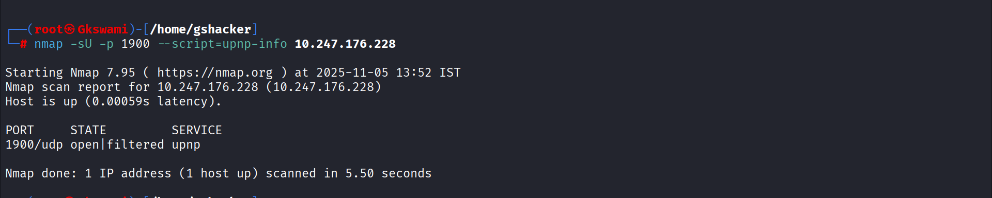

nmap: 1900/udp open|filtered upnp (10.247.176.228)
- (If M-SEARCH replied) include the raw SSDP response and LOCATION URL pointing to device description XML.

Recommendation:- Immediately verify whether UPnP is required. If not, disable UPnP/SSDP.
2. Block/deny UDP 1900 at network perimeter firewalls for external-facing interfaces.
3. Patch device/OS and restrict UPnP to trusted internal networks only.
4. If UPnP must remain enabled, implement monitoring and whitelisting for management interfaces.

Tool used: Nmap

General Guidelines

Validate Input and Output
The input that the server receives from the user can lead to malicious code entering the server. Similarly, the output shown to the user can transmit malicious code to the client system. All user input and output should be checked to ensure it is both appropriate and expected. Input validation should be done on the client-side as well as on the server-side.
There are three main models to consider about when designing a data validation strategy.
Accept Only Known Valid Data
A character set may be defined for each field where input from the user is accepted. E.g. “A-Z, a-z, @,., 0-9, _” is a character set for a field that accepts user email.
Reject Known Bad Data
A character set of bad data may be defined for the site that has to be rejected. E.g. “CREATE, DROP, OR”
Sanitize Known Bad Data
A character set of bad data is defined and any input field that has such a character is modified. E.g. “If there is a single quote (‘) in the data, it is replaced with two single quotes.”
All methods must check:
- Data Type
- Syntax
- Length
It is recommended to use the strategy of “Accept only known data”. Further all the allowed input/output data must be sanitized on the server side by replacing scripts tags, sent as part of user input/output, with appropriate representations.
For example
- “<” by &lt;
- “>” by &gt;
- “(“ by &#40

This would avoid scripts from being executed on the client side.
Client-side input must also be checked for URL encoded data. URL encoding sometimes referred to as percent encoding, is the accepted method of representing characters within a URI that may need special syntax handling to be correctly interpreted. This is achieved by encoding the character to be interpreted with a sequence of three characters. This triplet sequence consists of the percentage character “%” followed by the two hexadecimal digits representing the octet code of the original character. For example, the US-ASCII character set represents a space with octet code 32, or hexadecimal 20. Thus, its URL-encoded representation is %20.
Other common characters that can be used for malicious purposes and their URL encoded representations are: -
# | Character | URL encoded
 | ‘ | %27
 | “ | %22
 | ; | %3b
 | < | %3c
 | = | %3d
 | > | %3e
 | ) | %29
 | ( | %28
 | space | %20

All input validation checks should be completed after the data has been decoded and validated as acceptable content (e.g. maximum and minimum lengths, correct data type, does not contain any encoded data, textual data only contains the characters a-z and A-Z etc.)
A one-time check on the database is to be made for invalid malicious data. This would enable removal of input that has not been validated in earlier sessions. As otherwise the invalid data may cause script execution on the user’s browser.

Session Management / Strong session tracking
Session Tokens on Logout
In shared computing environments, session tokens take on a new risk. If the session tokens are not invalidated after logout, they can be reused to gain access to the application. It is imperative for the application to remove the cookies from both the server and the client side after the user has logged out. The user session maintained on the server side must also be invalidated immediately after logout.
Session Time-out
All the user Session tokens must be timed-out after a certain interval of user inactivity. The Session tokens that do not expire on the HTTP server can allow an attacker unlimited time to guess or brute force a valid authenticated session token. If a user's cookie file is captured or brute-forced, then an attacker can use these static-session tokens to gain access to that user's web accounts. Additionally, session tokens can be potentially logged and cached in proxy servers that, if broken into by an attacker, may contain similar sorts of information in logs that can be exploited if the particular session has not been expired on the HTTP server.
Session Token Transmission
If a session token is captured in transit through network interception, a web application account is then trivially prone to a replay or hijacking attack. Typical web encryption technologies include Secure Sockets Layer (SSLv2/v3) and Transport Layer Security (TLS v1) protocols in order to safeguard the state mechanism token.
Some more key points to remember:
Session ID’s that are used should have the following properties:
- Randomness.
  - Session Ids must be randomly generated.
  - Session Ids must be unpredictable.
  - Make use of non-linear algorithms to generate session ID’s
- Session ID Size
  - The size of a session ID should be large enough to ensure that it is not vulnerable to a brute force attack.
  - The character set used should be complex. i.e. Make use of special characters.
  - A length of 50 random characters is advised.
Salted Hashing
What is salted hashing?
The process starts with 2 elements of data:
1.) A clear text string (this could represent a password for instance).
2.) The salt, a random seed of data. This is the value used to augment a hash in order to ensure that 2 hashes of identical data yield different output.
In pseudo code we generate a salted hash as follows:
1.) Get the source string and salt as separate binary objects
2.) Concatenate the 2 binary values
3.) SHA hash the concatenation into Salted Password Hash
4.) Base64 Encode (concat (Salted Password Hash, Salt))
Credentials should be encrypted using salted hashes, so that even if the hashes are sniffed the possibility of replay attack does not exist.
References: http://www.owasp.org/images/3/33/Salted_Hashes_Demystified.doc
Cache Control Directives
Pages that contain sensitive information should not be stored in the local cache of the browser. To enforce this, HTTP directives need to be specified in the response. These HTTP directives need to be used to prevent enlisting of links on the browser history. The following HTTP directives can be sent by the server along with the response to the client. This would direct the browser to send a new request to the server each time it is generated.
Expires: <a previous date>, for e.g. Expires: Thu, 10 Jan 2020 19:20:00 GMT

Cache-Control: private
- Cache-Control: no-cache
- Cache-Control: no-store
- Cache-Control: must-revalidate
- Pragma: no-cache

The directive “Cache-Control: must-revalidate” directs the browser to fetch the pages from the server rather than picking it up from the local “Temporary Internet Folders”. It also directs the browser to remove the file from the temporary folders.

